**LAB EXPERIMENT # 04**

|  |
| --- |
| **Make Basic Node js and Python Apps** |

|  |  |
| --- | --- |
| **Student Name:** | **Roll No:** |

**Objective:**

In this lab, you'll be able to learn:

* Make a Basic App
* Write Simple basic API
* Run App
* Test Project and API

### **Introduction:**

In this lab, you will gain hands-on experience in building basic applications using Node.js and Python. You will start by creating a simple app in both environments, followed by writing a basic API to handle requests and responses. Additionally, you will learn how to run the application and test its functionality to ensure it works as expected. By the end of this lab, you will have a foundational understanding of setting up and running basic applications and APIs in both Node.js and Python.

**Procedure:**

**Step 1: Create a Node.js App**

* Open VS Code and create a new folder.
* Open a terminal in VS Code.
* Initialize a Node.js project:

**npm init -y**

This creates a package.json file.

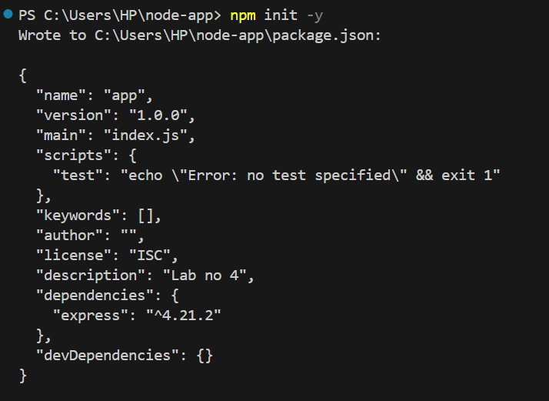

**Step 2: Install Express.js**

We will use Express.js to build a basic API.

**npm install express**

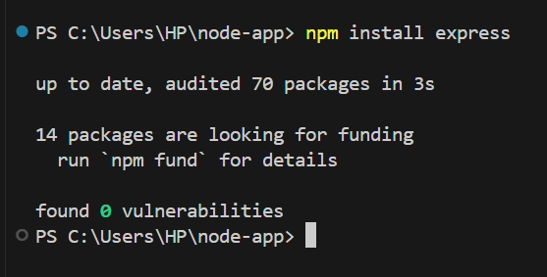

**Step 3: Write a Basic Node.js API**

* Create a new file server.js in your project folder.
* Add the following code:

**Code:**

const express = require('express');

const app = express();

const port = 3000;

app.get('/', (req, res) => {

res.send('Hello, Node.js API!');

});

app.get('/api/data', (req, res) => {

res.json({ message: "This is a basic Node.js API response." });

});

app.listen(port, () => {

console.log(`Server running at http://localhost:${port}`);

});

**Step 4: Run the Node.js App**

Run the app using:

**node server.js**

You should see output:

**Server running at** [**http://localhost:3000**](http://localhost:3000)

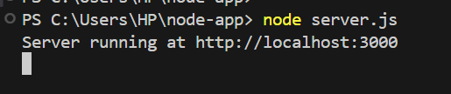

**Step 5: Test the API**

* **Open a browser and visit:**

http://localhost:3000/ → Should display "Hello, Node.js API!"

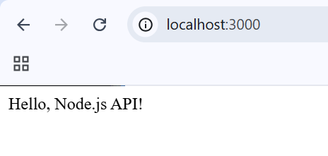

* **Visit:**

http://localhost:3000/api/data → Should return JSON data.

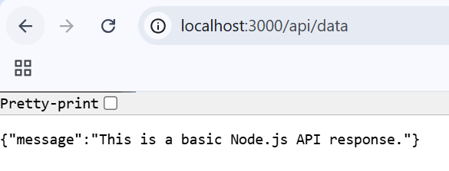

**Python Basic App & API**

**Step 1: Create a Python App**

* In VS Code, create a new folder.
* Inside the folder, create a new file.

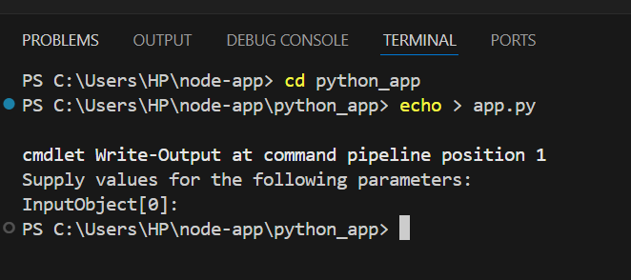

**Step 2: Install Flask**

Flask is a lightweight web framework for Python. Run the following in the terminal:

**pip install flask**

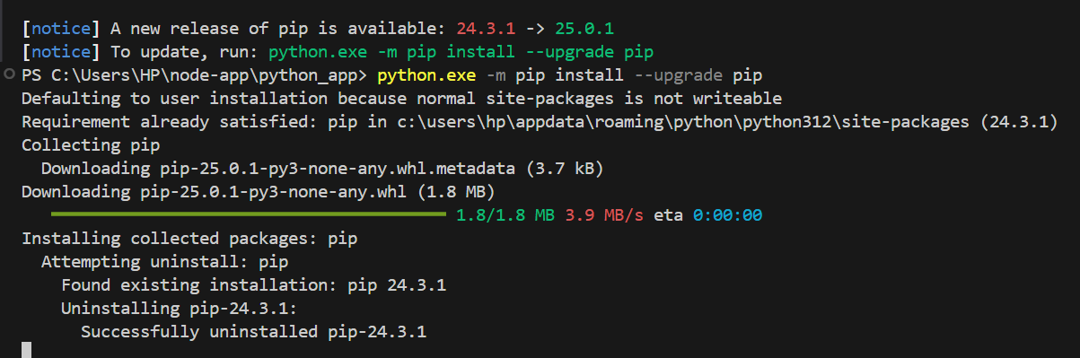

**Step 3: Write a Basic Python API**

Add the following code to app.py:

**Code:**

from flask import Flask, jsonify

app = Flask(__name__)

@app.route('/')

def home():

return "Hello, Python API!"

@app.route('/api/data', methods=['GET'])

def get_data():

return jsonify({"message": "This is a basic Python API response."})

if __name__ == '__main__':

app.run(debug=True, port=5000)

**Step 4: Run the Python App**

Execute the following command:

**python app.py**

You should see:

* Running on http://127.0.0.1:5000/

(Press CTRL+C to quit)

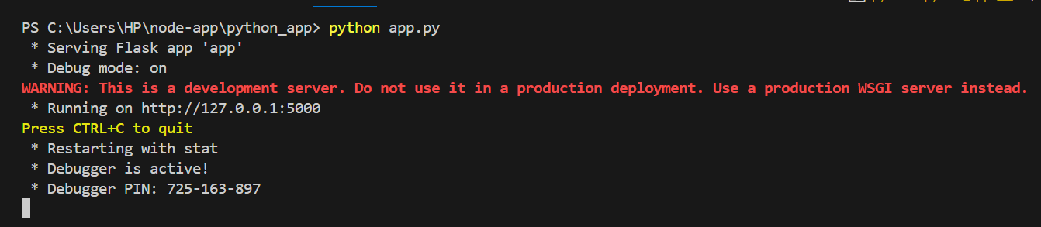

**Step 5: Test the API**

* **Open a browser and visit:**

http://127.0.0.1:5000/ → Should display "Hello, Python API!"

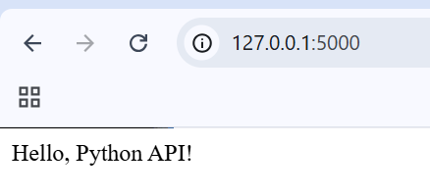

* **Visit:**

http://127.0.0.1:5000/api/data → Should return JSON data.

